**Perform the following DB operations using MongoDB.**

**1. Create a database “Student” with the following attributes Rollno, Age, ContactNo, Email-**

**Id.**

**2. Insert appropriate values**

**3. Write query to update Email-Id of a student with rollno 10.**

**4. . Replace the student name from “ABC” to “FEM” of rollno 11**

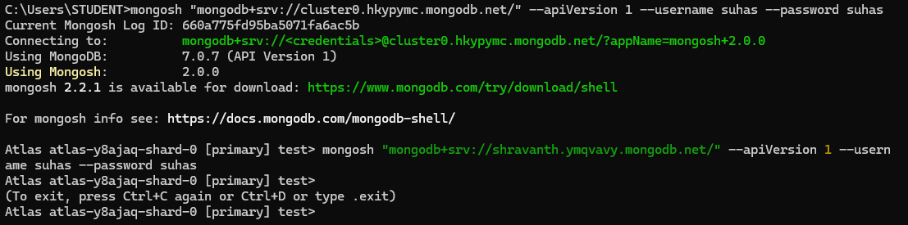

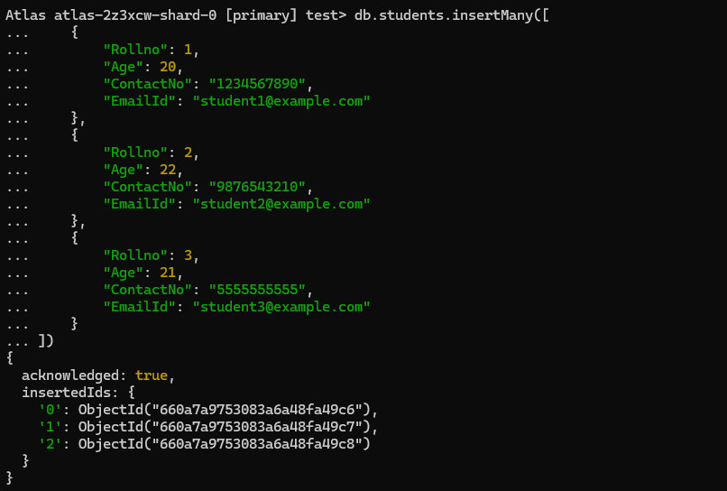

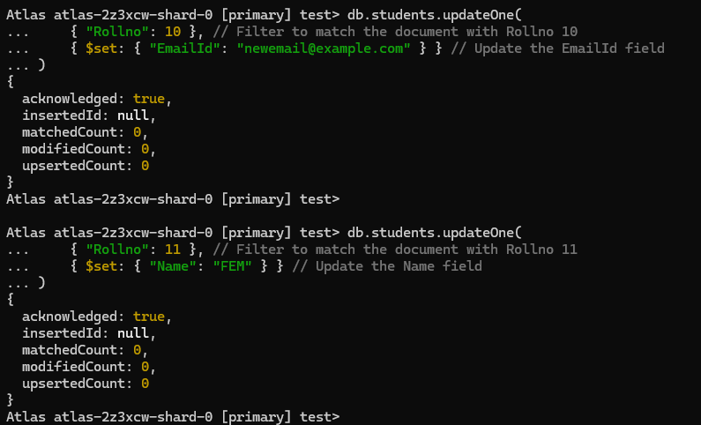

II. Perform the following DB operations using MongoDB.

1. Create a collection by name Customers with the following attributes.

Cust_id, Acc_Bal, Acc_Type

2. Insert at least 5 values into the table

3. Write a query to display those records whose total account balance is greater than

1200 of account type ‘Z’ for each customer_id.

4. Determine Minimum and Maximum account balance for each customer_i

